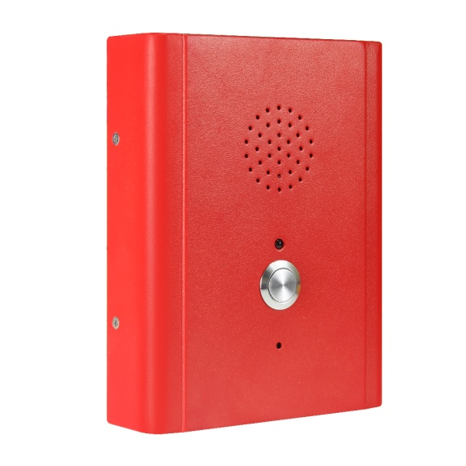 | - Standard Analog / VoIP phone  - Robust housing, constructed of Cold-rolled steel body,Red Color  - Vandal resistant metal button  - With indicator light  - Hands free operation  - Wall mounted, simple installation  - Weather proof protection: IP55-IP65  - Phone line powered (Analogue)  - POE, or 12V DC (SIP)  - RJ45 Port for SIP connection  - 4 X Tamper proof screws for mounting  - CE, FCC, IK10, RoHS, ISO9001 compliant
The Hands free Telephone is designed to meet the needs of client who experience loss through vandalism. Ideal for parking lots, lifts/elevators, hotels, doorway, railway/metro platforms, hospitals, police stations, ATM machines, stadiums, outside building etc.  Housed in cold rolled steel box and manufactured to a high standard, these telephones offer increased resistance to vandalism, and ensure that the primary function of communications is maintained at all times.  Extremely easy to install. The cable entrance is on the back of the phone to prevent from artificial damage, while the keypad is weather and vandal resistant.
  SIP-VoIP TECHNICAL SPECIFICATIONS
  Power:
  12-24V DC, or POE: IEEE802.3af (Optional)
  Port:
  WAN: 10/100Base- T RJ-45 for LAN, Auto MDIX
  LAN: 10/100Base- T RJ-45 for PC, Auto MDIX
  Power Consumption:
  Idle: 1.5W/ Active: 1.8W
  Voice Features
  - Support SIP 2.0 (RFC3261)
  - Codec: G.711A/u, G.7231 high/low, G.729, G.722
  - Echo cancellation: Support G.168 and hand-free can support 96ms
  - Supports full duplex.
  - SIP support SIP domain, SIP authentication (none, basic, MD5), DNS name of server, peer to peer
  - DTMF: SIP info, DTMF Relay, RFC2833
  - Call control feature: Flexible dial map, support hot-line
  Network Features
  - WAN/LAN: support Bridge mode
  - Support static IP address
  - Support DHCP get IP on WAN port
  - Support VLAN
  - Support web config
  - Data Protocols: IPv4, TCP, UDP, ICMP, ARP, DNS and DNS SRV for SIP Signaling
STANDARD ANALOGUE  As a standard analogue telephone, this unit provides basic telephone functions and can be connected to any standard two-wire telephone line, including analogue PABX lines and PSTN.  ANALOGUE  Dialing  MF (tone)  Power supply  Drawn from telephone line  Lightning / Transients  Protection to ITU-T k.21 enhanced levels  Programming  Can be programmed remotely by DTMF tone or use keypad  TECHNICAL SPECIFICATIONS  Casing Material  Cold-rolled steel  Button Material  Stainless steel button  Microphone  Electret microphone  Keypad  Internal keypad for programming  Temperature  Operating: -30°C to +65°C  Storing: -40°C to +75°C  Weather Resistance  IP55-IP65  Ringing Tone  Analog: Shrill warble tone 80 dBA @ 1 metre typical  SIP: Shrill warble tone 90 dBA @ 1 metre typical  M.T.B.F.  Calculated to have an M.T.B.F. in excess of 50,000 hours using |  | DIMENSIONS  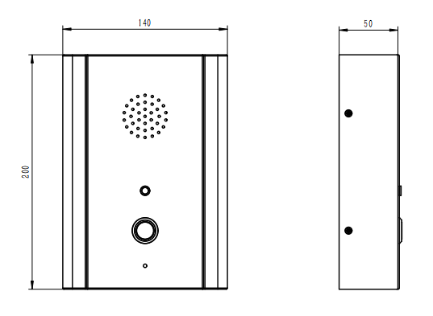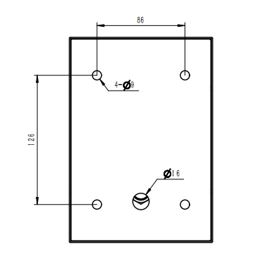  (Measured in mm)  APPROVALS    This mark indicates compliance with the:  Radio & Telecommunications Terminal Equipment Directive 2004/108/EC    This mark indicates compliance with the:  FCC Part 15 Subpart B Class B  PACKAGE  Unit size: 200 *140 *50 (mm)  Carton size: 340 *235 *165 (mm)  Packaging materials: pearl cotton, carton  Gross weight: 3 KG  Net weight: 2 KG

